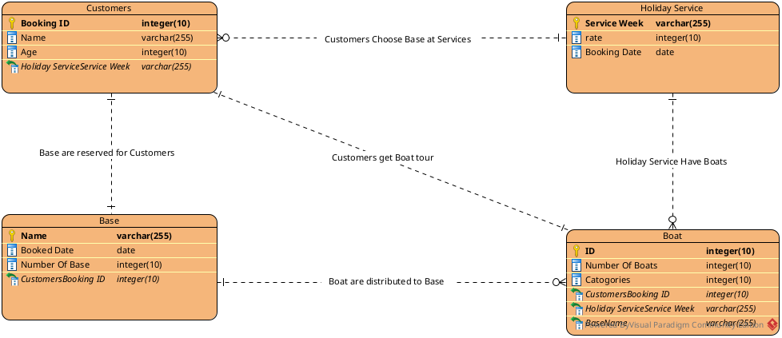

#Doc

To deal with the reservation of Holiday service we create a Customers Entity cointaining (Booking ID, Name, Age ) as it’s attributes .

The Entity Holiday service with (Service Week, rate, Booking Date ) as attribute act as mediator brtween the abse and the customers.

Base Entity with (Name, Booked Data, Number of Base ) are the appointed base to the customer that deal with every service to be perovided.

Boat Entity with (ID, Number Of Boats, Catagories) are the main feature of this tour.

Now for relationship

Customer book the Holiday service so with many to many relationship , a family or a group of people can book one service at a time. Then customers are appointed to baases among 2 bases with one to one relationship. Customer get Boat to complate the tour with one to one relationship . Which is provided by the base they were appointed cause bases cointain many boat so we can say boat and base are in many to one relationship.

